Media Contacts:
USA: Larry Smith email larry.smith@wireworldcable.com
Intl: Martin Harding email martin@avemea.com

Wireworld RCA Plug Tonearm Cables

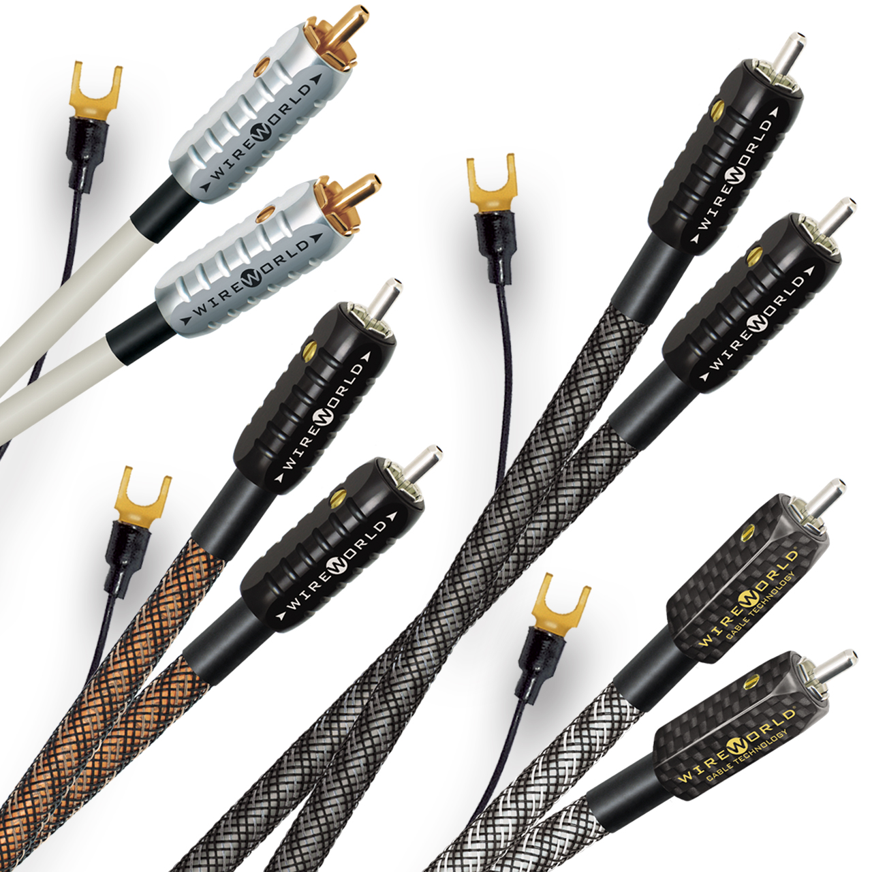
FORT LAUDERDALE, FL, July 10th, 2023 — Wireworld Cable Technology, a long-standing leader in the audiophile and professional A/V cable industry, announces the release of four new cables for turntables with RCA plug connections. These four cables, named Solstice 8, Eclipse 8, Silver Eclipse 8 and Platinum Eclipse 8, feature Wireworld’s patented DNA Helix conductor geometry and Silver Tube RCA plugs, along with ultra-quiet COMPOSILEX 3 insulation and external ground wires, to provide exceptionally lifelike sound quality.

The four cables differ in their conductor materials and RCA plugs, which vary considerably in cost. The conductors in the top-level Platinum Eclipse 8 are made of OCC-7N (Ohno Continuous Cast 99.99999% pure) solid silver and the patented plugs are made of carbon fiber with silver-clad contacts for the lowest possible noise. Silver Eclipse 8 has OCC-7N silver-clad copper conductors and Silver Tube RCA plugs. Eclipse 8 has OCC-7N copper conductors and Silver Tube RCA plugs. Solstice 8 has oxygen-free copper conductors and 24K gold plated plug contacts. Flexible ground wires with small gold spade lugs are included with all four cables. The cables are also physically flexible enough to avoid interfering with the isolation provided by suspended turntables.

Great analog playback systems are prized for their lively organic portrayal of instruments and voices. However, some of those wonderful musical details and dynamics are lost as they pass through conventional tonearm cables. In learning to minimize those losses, Wireworld developed listening tests that compare real world cables to virtually perfect direct connections. Those objective tests led to the development of the patented DNA Helix conductor geometry, which minimizes the electromagnetic ‘eddy current’ losses of conventional stranded and solid core designs. Wireworld’s COMPOSILEX 3 insulation takes those improvements a step further by minimizing the triboelectric noise that would otherwise mask quiet musical details. These exclusive features are instrumental in creating the feeling of a live musical performance.

These cables are available in standard lengths of 1m, 1.5m and 2m. Custom lengths are also available.

Retail Pricing
Solstice 8 (SOR) $119/1m, $131/1.5m, $143/2m
Eclipse 8 (ERT) $420/1m, $480/1.5m, $540/2m
Silver Eclipse 8 (SRT) $540/1m, $660/1.5m, $780/2m
Platinum Eclipse 8 (PRT) $1200/1m, $1550/1.5m, $1900/2m

About Wireworld
Wireworld Cable Technology, founded by industrial designer David Salz in 1992, manufactures digital and analog cables for home and professional A/V applications, including HDMI, USB, Ethernet, fiber optic, interconnect, power and speaker cables. Wireworld has earned numerous awards and a loyal following for producing cables with objective perceptual testing, innovative patented designs, premium materials, and exceptional manufacturing quality. For more information, visit www.wireworldcable.com

